**B. V. V. Sangha’s**

**BASAVESHWAR ENGINEERING COLLEGE (AUTONOMOUS),**

**BAGALKOT-587 102**



**DEPARTMENT OF COMPUTER SCIENCE & ENGINEERING**

**For the academic year**

**2020-2021**

**Project Phase-II Report**

**on**

**Self Driving Car** (mini-prototype)

Under the Guidance of

**Prof.S.S.Yendigeri**

**Submitted by:**

| **Name** | **USN** |
| --- | --- |
| **Gururaj Otageri** | **2BA16CS026** |
| **Megha Hadagali** | **2BA17CS036** |
| **Prithvi Allurkar** | **2BA17CS049** |
| **Ninganagouda Kalasanagoudra** | **2BA17CS039** |

B. V. V. Sangha’s

**BASAVESHWAR ENGINEERING COLLEGE (AUTONOMOUS),**

**BAGALKOT-587 102**

**Department of Computer Science & Engineering**

**2020-2021**



**CERTIFICATE**

This is to certify that **Mr. Gururaj Otageri (2BA16CS026), Miss. Megha Hadagali (2BA17CS036), Miss. Prithvi Allukar (2BA17CS049), Mr. Ninganagouda Kalasanagoudra (2BA17CS039),** have satisfactorily completed the Project Phase-II on the work entitled “Self Driving Car**”**, in partial fulfillment for the award of the degree of Bachelor of Engineering in Computer Science and Engineering of Visvesvaraya Technological University, Belagavi, during the academic year 2020-2021.

PLACE: Bagalkot

DATE:

Guide Head of the Department Principal

**Prof. S S Yendigeri Dr. V. B. Pagi** **Dr. S. S. Injaganeri**

**ACKNOWLEDGMENT**

The satisfaction and euphoria that accompany the completion of any task would be incomplete without the mention of the people who made it possible, whose consistent guidance and encouragement crowned our effort with success.

We consider it as our privilege to express gratitude to all those who guided in the completion of my Project Phase-I.

First and foremost, we would like to express our deep sense of gratitude and indebtedness to our beloved project guide S.S.Yendigeri, Asst. Professor in the Department of Computer Science and Engineering, who has been our source of inspiration. She has been especially enthusiastic in giving her opinions and critical reviews. We have learned a lot throughout this semester with many challenges yet valuable experiences to complete this task. We will remember her contribution forever.

We thank our beloved Principal Dr. S. S. Injaganeri for his constant help and support throughout. Our special thanks to our Head of the department Dr. V. B. Pagi who supported us in making this project a successful one.

We would like to thank all the teaching and non-teaching staff of the Department of Computer Science and Engineering for their coordination and support.

**ABSTRACT**

Self-driving cars are autonomous vehicles that can drive by themselves without any human interference and have the potential to mark the technological revolution of the next decade. This work presents the development of a low-cost prototype of a miniature self-driving car model using simple and easily available technologies. The objective of the work is to avoid accidents caused due to driver faults. In this prototype, Raspberry Pi controller and H-bridge drives DC motors (rear wheels), and a servo motor (for front wheels) are used to realize vehicle automation. We use ultrasonic sensors for obstacle detection and avoidance and Raspberry Pi as the main processing module. A trained deep learning model is used for lane detection and following. Machine learning is an application of artificial intelligence (AI) that provides systems the ability to automatically learn and improve from experience without being explicitly programmed. Ours is a supervised regression problem between the car steering angles and the road images in real-time from the cameras of a car.

**Table Of Contents**

| **Chapter No** | **Heading** | **Page. No** |
| --- | --- | --- |
| 1 | Introduction | 1 |
| 2 | Proposed Methodology | 5 |
| 3 | Requirement Specification | 7 |
| 4 | System Design and Implementation | 10 |
| 5 | Experimentation and Result | 16 |
| 6 | Conclusion | 19 |
| 7 | References | 20 |

**1. INTRODUCTION**

**1.1 Overview**

With the growing wants for convenience, the technology currently tries to automate processes as much as possible. Also, in recent years we tend to see the rise in the number of accidents due to the increased number of vehicles and carelessness of the drivers.It currently looks necessary to hunt automation in vehicles. Therefore, to To solve this problem, the car would drive itself on the lane and possess integrated options like lane-detection,obstacle-detection and traffic sign detection

.

**1.2 Related literature**

The paper “Working model of Self-driving car using Convolutional Neural Network, Raspberry Pi and Arduino” by Aditya Kumar Jain[11] proposes the model that takes an image with the help of Pi cam attached with Raspberry Pi on the car. The Raspberry Pi and the laptop are connected to the same network, the Raspberry Pi sends the captured image to the Convolutional Neural Network. The image is gray-scaled before passing it to the Neural Network. Upon prediction, the model gives one of the four outputs i.e. left, right, forward , or stop. When the result is predicted corresponding Arduino signal is triggered which in turn helps the car to move in a particular direction with the help of its controller

**1.3 Issues Addressed / Issues Identified**

The mini-prototype of the proposed self-driving car consists of 3 modules: Lane detection and following, traffic sign detection and recognition and obstacle detection and avoidance. There were a few issues that were observed in the three modules mentioned.

**1.3.1 Lane Detection and Following**

The existing approaches failed to detect the lanes which are obscured by dirt fig. 1.1(a), tree shadows fig. 1.1(b) and bright lights fig. 1.1(c). The proposed method is implemented to resolve the aforementioned drawbacks encountered in existing approaches.

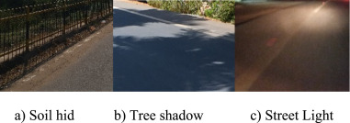



In this approach, its performance highly relies on the feature extraction and interpretation of the image data. Often the manually defined features and rules are not optimal. Errors can also accumulate from the previous processing stage to the next stage, leaving the final result inaccurate.

**1.3.2 Advantages of ML approach over the traditional approach**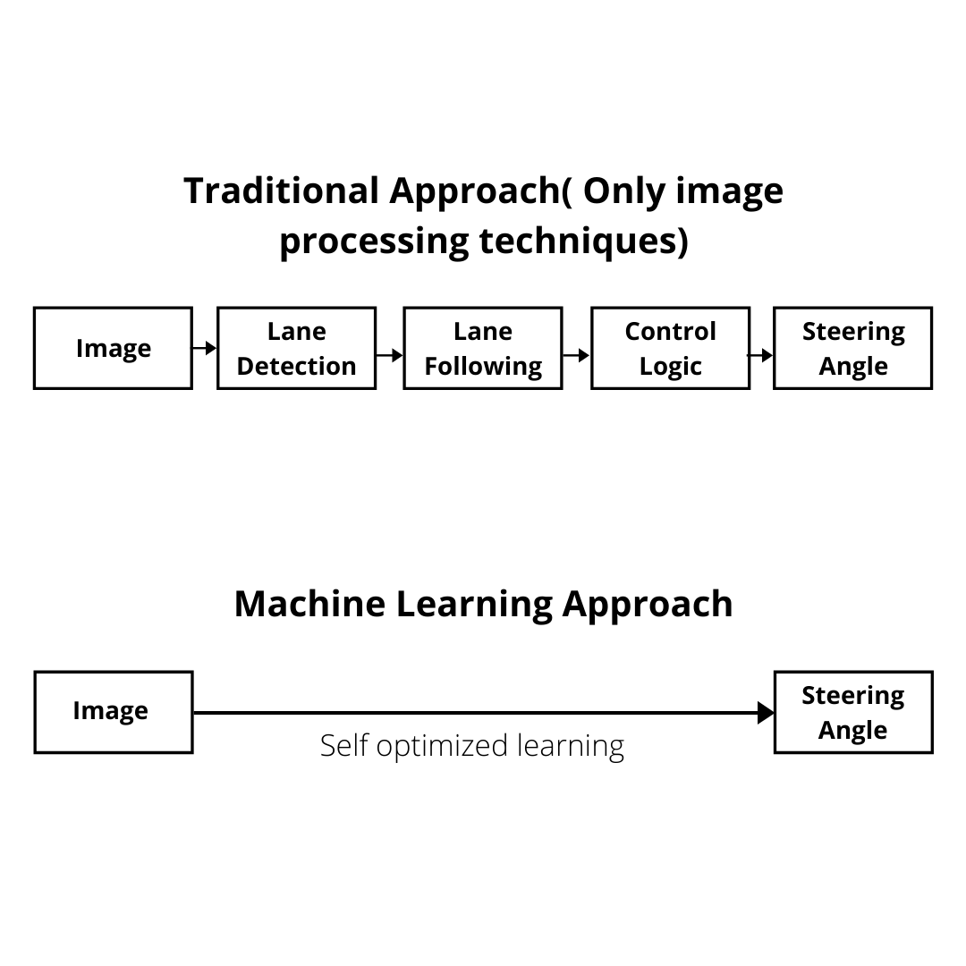

1) Better performance: Because the model is self-optimized based on the data to give maximum overall performance, the intermediate parameters are self-adjusted to be optimal.

2) Less Manual Effort: The traditional approach divides the task into several parts such as lane detection, path planning, and control logic, and they are often researched separately. But in the ML approach, there’s no need to take care of these processes individually.

**1.3.3 Limitations and challenges in TSDR(Traffic Sign Detection and Recognition)**

There are several challenges in developing a successful TSDR system. The performance of these systems is greatly affected by the surrounding conditions that affect road sign’s visibility fig. 1.2(a). The broken and damaged signs make it harder to detect and recognize fig. 1.2(b) and fig. 1.2(c).

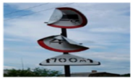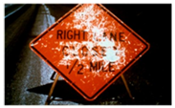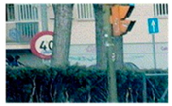



|  |  |  |
| --- | --- | --- |

**1.4 Problem Definition and Objectives of the Project work**

**1.4.1 Problem Statement**

Humans tend to cause undesired errors while driving which leads to accidents, injuries, risk & damage to life and property. Thus a way to overcome these problems is having automation in the field of automobiles by building a self-driving car that drives on its own on the lane and avoids obstacles and follows the traffic signals and signs.

**1.4.2 Objectives**

The mini-prototype of the proposed self-driving car consists of 3 modules: Lane detection and following, traffic sign detection and recognition and obstacle detection and avoidance.

1. **Lane Detection and Following**
2. To achieve the main objective of lane detection and tracking, a self-driving car should be able to detect, track and differentiate various roads for its proper movement on the road.

**2. Traffic Signals Detection and recognition**

1. The car should be able to detect traffic signals and follow the rules.

**3. Real-time Detection and Avoidance of Vehicles and Obstacles**

1. The Car should be able to detect the vehicles and pedestrians around it and avoid collisions.

**1.5 Proposed approaches**

The task of lane detection and the following is divided into three different phases:

1. Data Collection
2. Training
3. Model Deployment

The data to be collected for lane detection and following is the image of the road from the driver’s point of view from the car and the corresponding steering angle. This data needs to be used to train a deep learning model to predict the steering angle given an image.

Initially, the Raspberry Pi captures the road from the pi-camera and does preprocessing tasks, and sends the processed data to the processing unit (GPU in our case). The processing unit does mainly two tasks, i)Lane detection and angle prediction: Lane Detection is carried out by a Machine learning model developed by training on manually driven data ii)Object Detection and positioning: The Tensorflow Object Detection model API is a publicly available model that detects around 90 different objects. This model API is used to detect the objects around the car. After getting results from the models, the processing unit sends back the processed data to the Raspberry Pi. The Raspberry Pi collects the data processed and generates the commands for the motor driver and the servo motor. Based on results the car drives itself.

**2. PROPOSED METHODOLOGY**

**2.1. Introduction**

Considering the issues in the existing system, instead of going for traditional image processing techniques for lane following, we propose to build a deep learning model that predicts the steering angle for the given image. Tensorflow object detection API and ultrasonic sensors for object detection and avoidance and recognition of traffic signals and signs.

**2.2 Different stages**

**2.2.1 Lane Detection and Following**

This is to be implemented by training a deep learning model that outputs the steering angle of the car given a particular image. Data required for training the model will be collected by manually driving the car. Image from the camera and corresponding steering angle is our data. The ML model is then trained on the collected data to predict the required steering angle.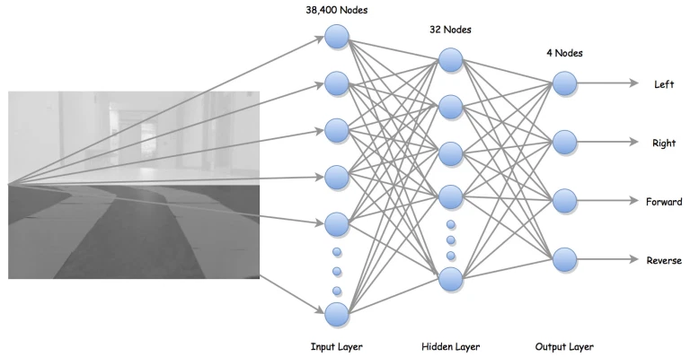

IMAGE DATA



The task of lane detection and the following is divided into three different phases, data collection, training, and model deployment. The data to be collected for lane detection and following is the image of the road from the driver’s point of view from the car and the corresponding steering angle. This data needs to be used to train a deep learning model to predict the steering angle given an image.

**2.2.2 Traffic Signals Detection and recognition**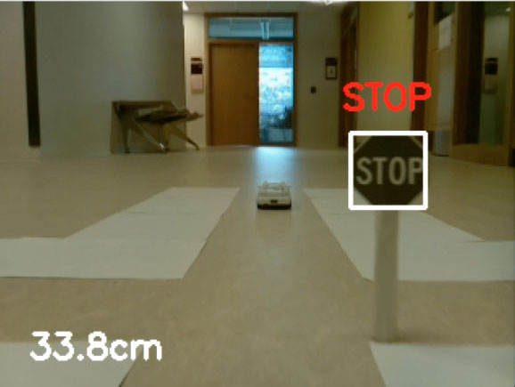

To detect the traffic signals and signs we use TensorFlow object detection API to detect and recognize traffic signals and signs and react accordingly.





**2.2.3 Object Detection and Avoidance**

The Tensorflow object detection API is an open-source framework built on top of TensorFlow that makes it easy to construct, train and deploy object detection models. There are already pre-trained models in their framework which are referred to as Model Zoo. It includes a collection of pre-trained models trained on various datasets such as the COCO (Common Objects in Context) dataset, the KITTI dataset, and the Open Images Dataset.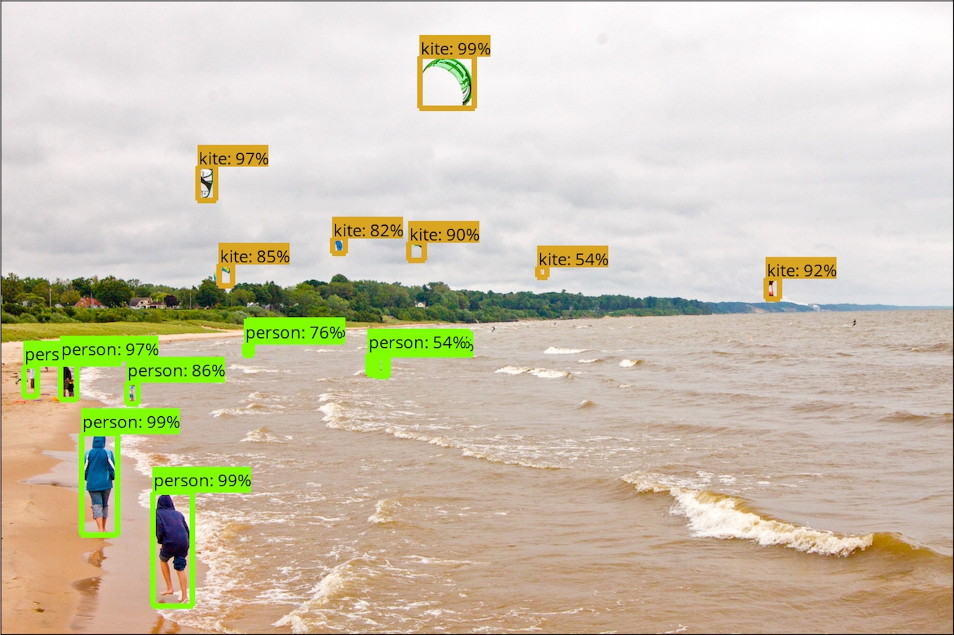



**2.3 Proposed Model diagram and flowchart**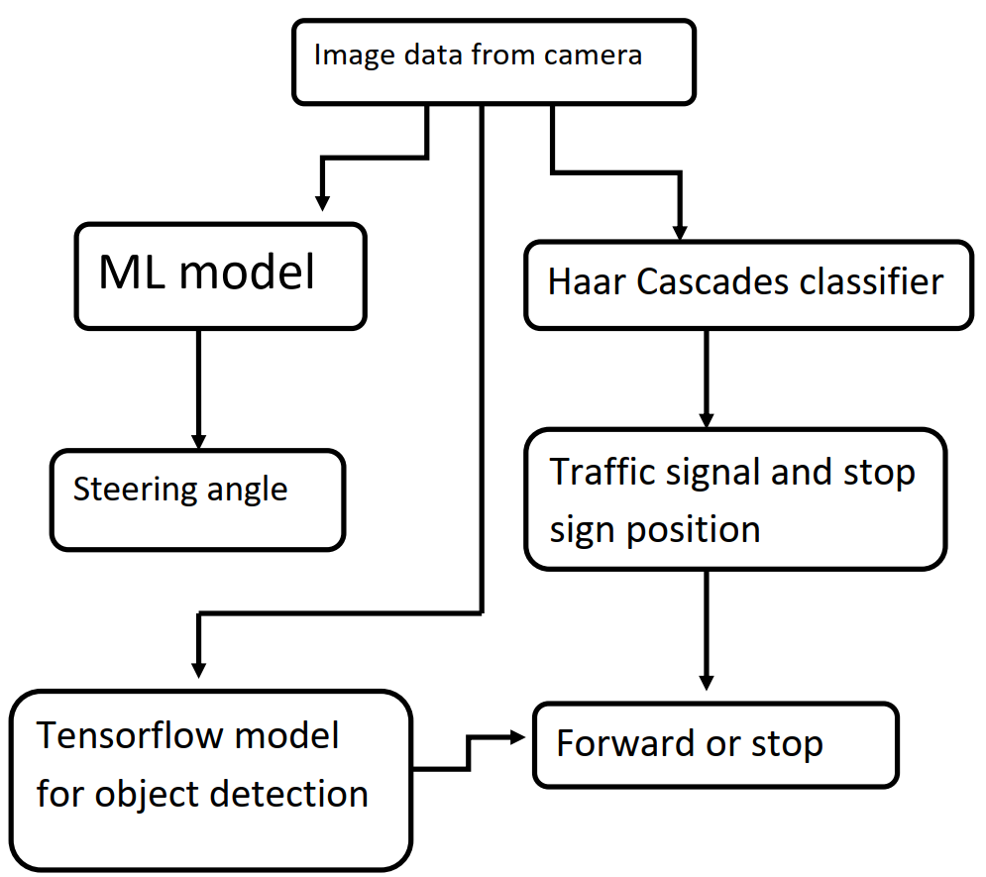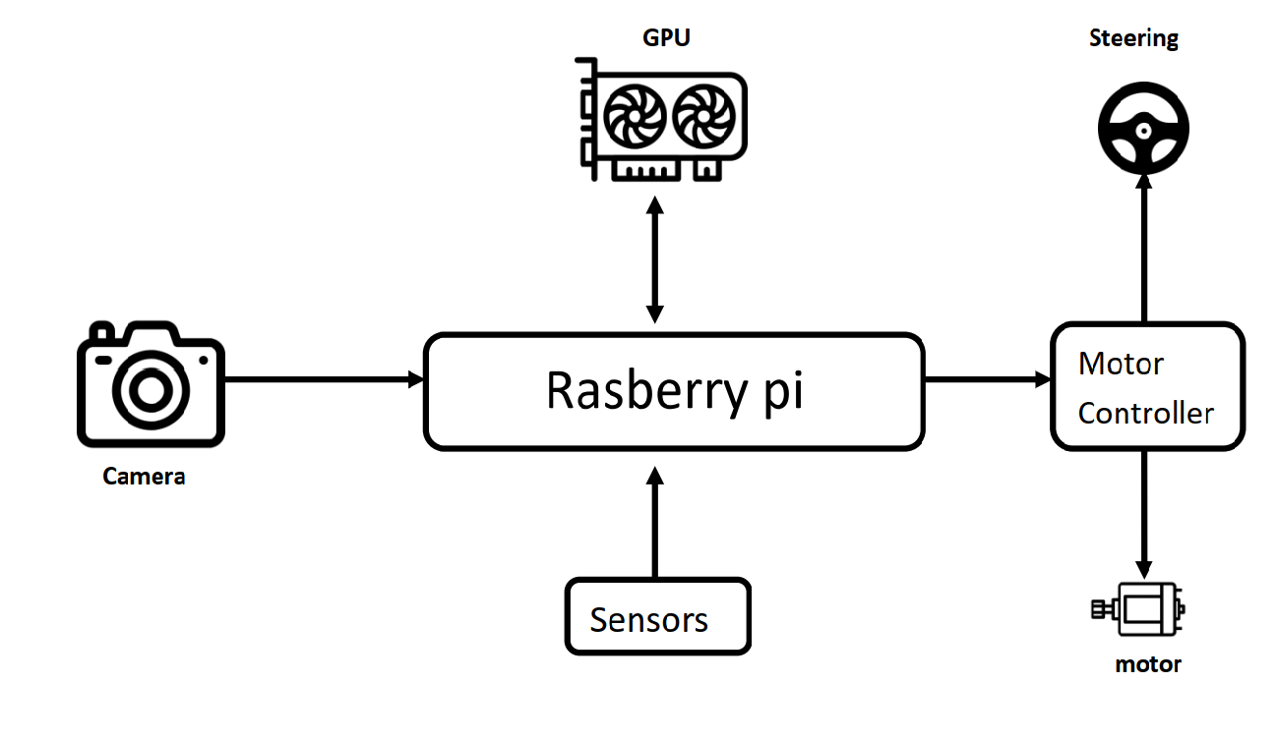



**3. Requirement Specification**

**3.1 Hardware Requirements**

1. Raspberry Pi

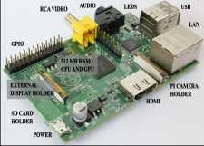

The Raspberry Pi is a credit-card-sized single-board computer. There are currently five Raspberry Pi models in the market: the Model B+, the Model A+, the Model B, the Model A, and the Compute Module (currently only available as part of the Compute Module development kit).

The A and B use the same PCB, whilst the B+ and A+ are new designs but of very similar form factors. The Compute Module is an entirely different form factor and cannot be used standalone.

In this project, we have used model B Rev 2. comes with 512 MB RAM, two USB ports and a 10/100 Ethernet controller.

1. Pi Camera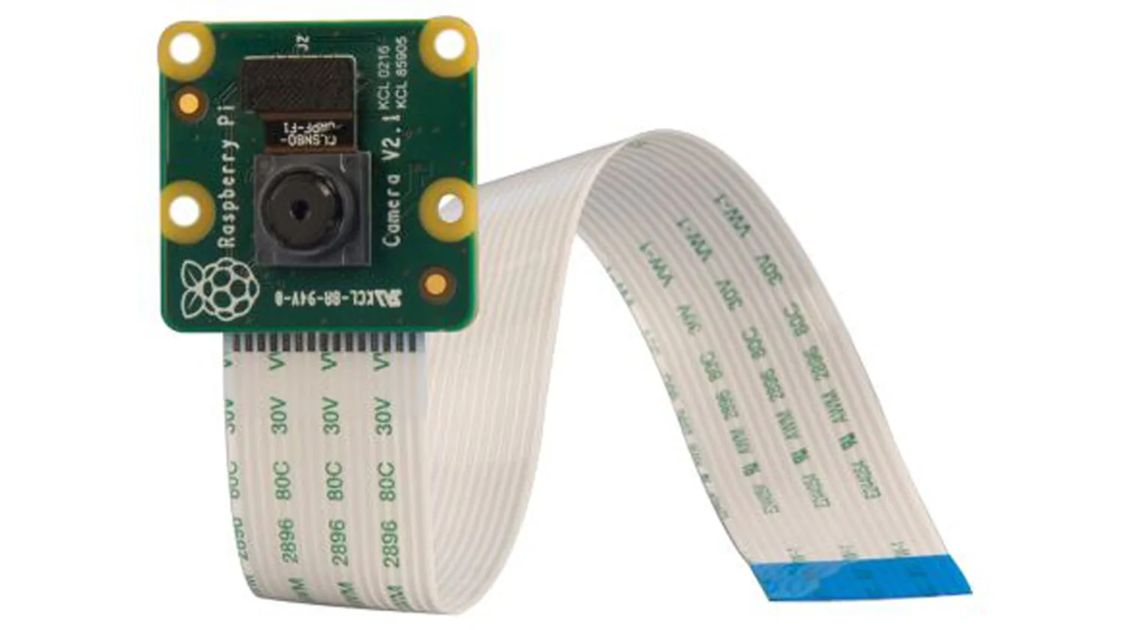

It is the camera shipped along with Raspberry Pi. A Pi camera module is also available which can be used to take high-definition videos as well as still photographs.



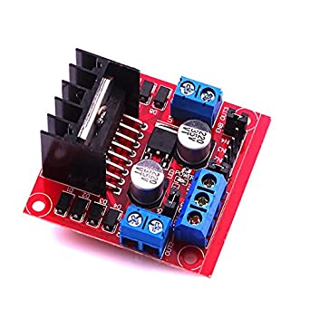

3. L298n Motor driver

This L298N Motor Driver Module is a high-power motor driver module for driving DC and Stepper Motors. This module consists of an L298 motor driver IC and a 78M05 5V regulator. L298N Module can control up to 4 DC motors, or 2 DC motors with directional and speed control. 

4. Servo motor

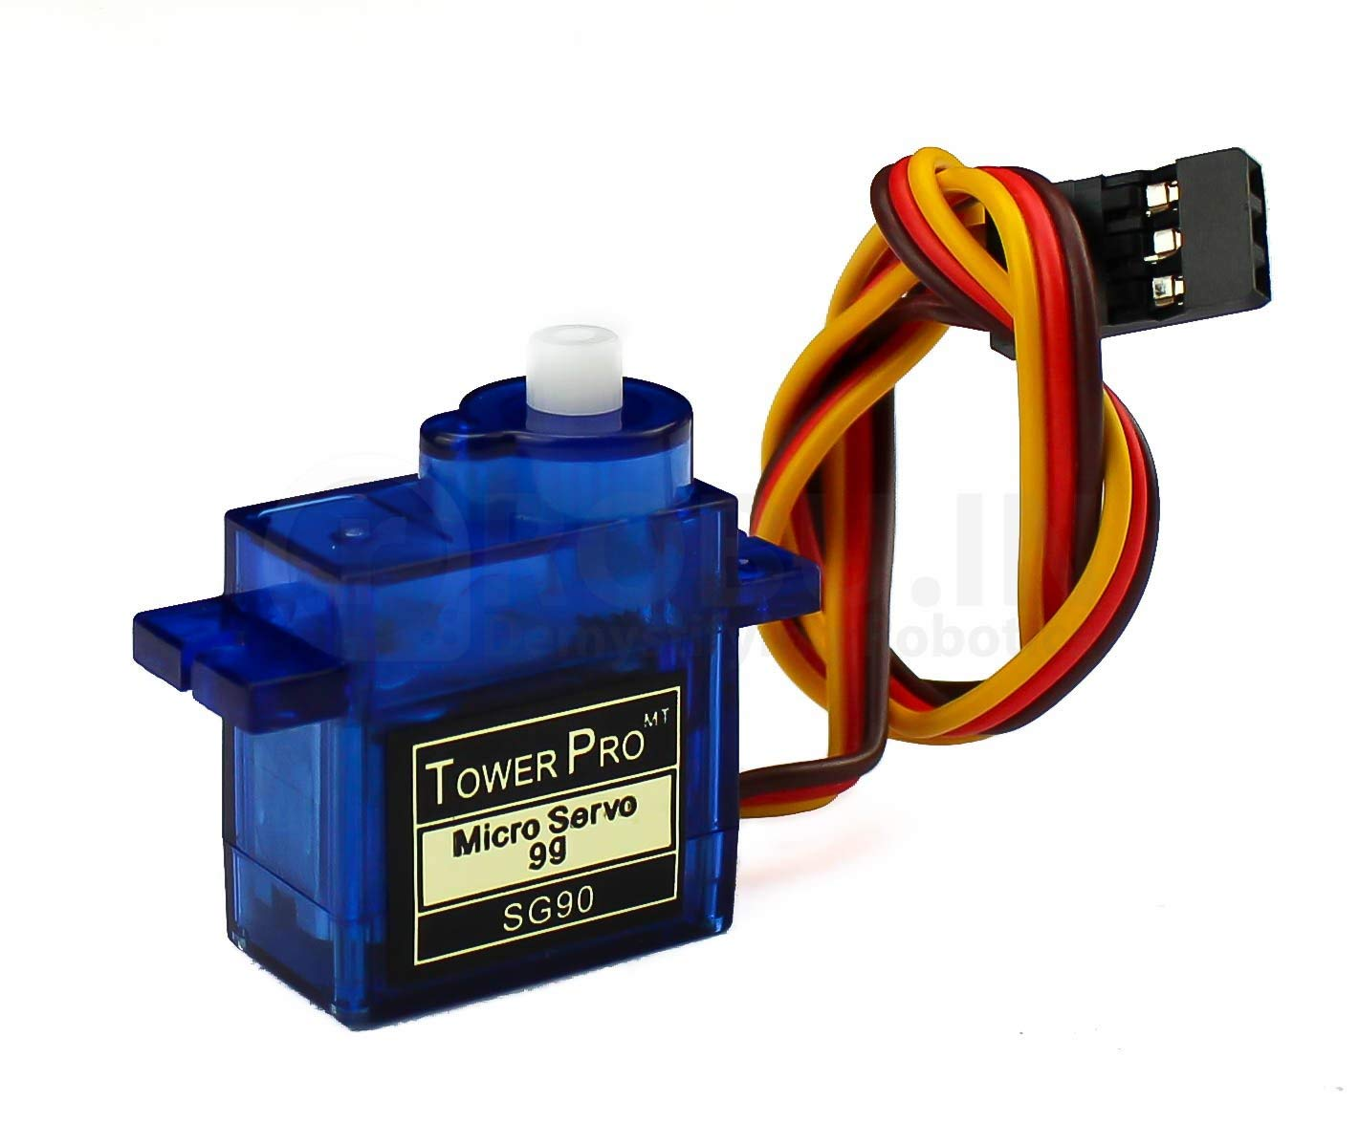

A servo motor is a rotary actuator or linear actuator that allows for precise control of angular or linear position, velocity and acceleration. It consists of a suitable motor coupled to a sensor for position feedback. It also requires a relatively sophisticated controller, often a dedicated module designed specifically for use with servomotors.

5 .Ultrasonic sensor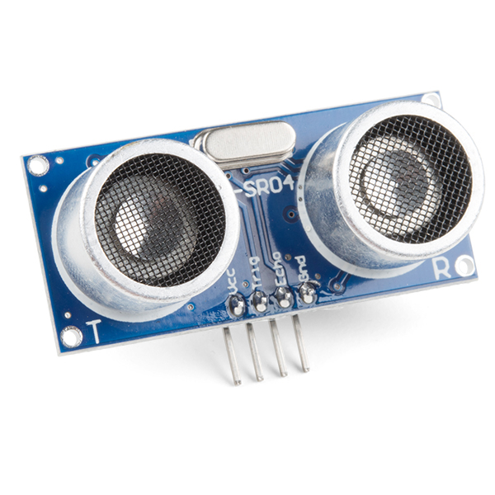

An ultrasonic sensor is an electronic device that measures the distance of a target object by emitting ultrasonic sound waves and converts the reflected sound into an electrical signal. Ultrasonic waves travel faster than the speed of audible sound i.e., the sound that can be heard by humans. Ultrasonic sensors have two main components: the transmitter (which emits the sound using piezoelectric crystals) and the receiver (which encounters the sound after it has traveled to and from the target).

**3.2 Software Requirements**

1. Raspbian OS 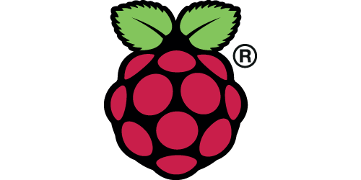

Of all the operating systems Arch, Risc OS, Plan 9, or Raspbian available for Raspberry Pi, Raspbian comes out on top as being the most user-friendly, best-looking, has the best range of default software, and optimized for the Raspberry Pi hardware. Raspbian is a free operating system based on Debian (LINUX), which is available for free from the Raspberry Pi website. 

1. Python 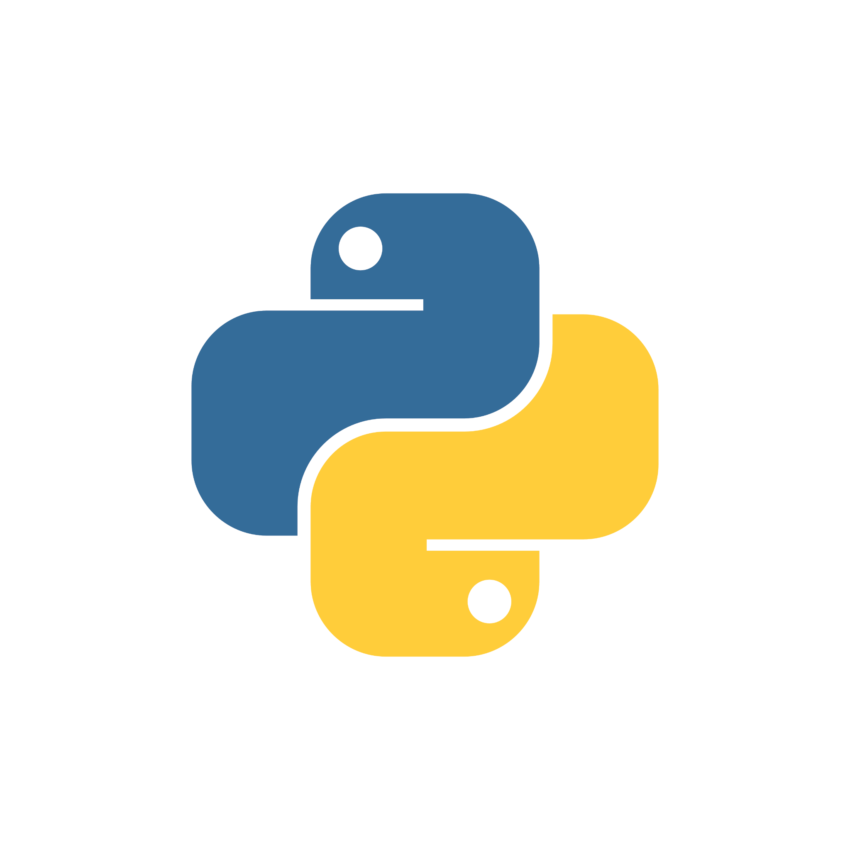

Python is a widely-used general-purpose, high-level programming language. Its syntax allows the programmers to express concepts in fewer lines of code when compared with other languages like C, C++or java.



The RPi.GPIO Python library allows you to easily configure and read-write the input/output pins on the Pi's GPIO header within a Python script. This package is not shipped along with Raspbian.

1. OpenCV

OpenCV is a huge open-source library for computer vision, machine 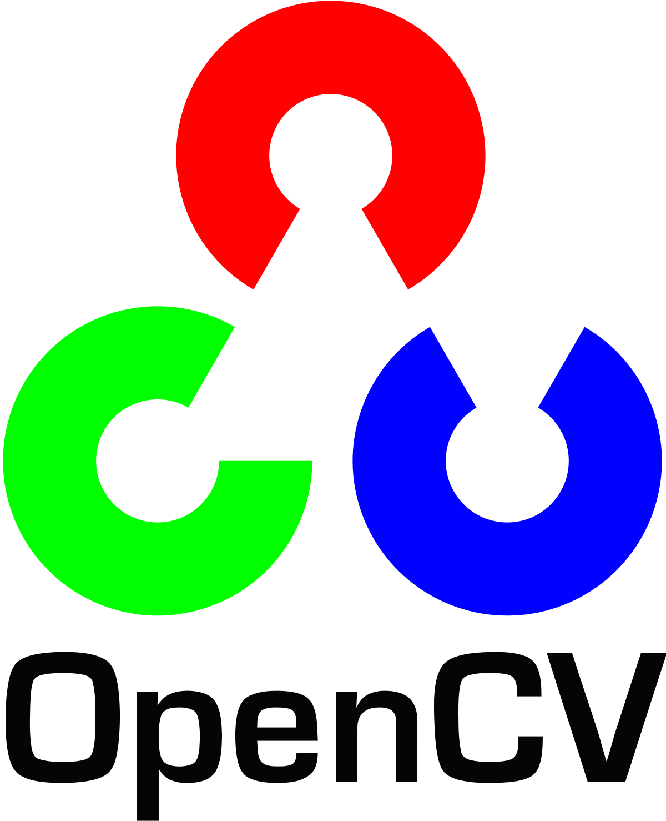learning, and image processing and now it plays a major role in real-time operation which is very important in today's systems. It has over 2500 optimized algorithms, including both a set of classical algorithms and the state of the art algorithms in Computer Vision, which can be used for image processing, detection and face recognition, object identification, classification actions, traces, and other functions. This library allows these features to be implemented on computers with relative ease, providing a simple computer vision infrastructure to prototype quickly sophisticated applications

The library is used extensively by companies like Google, Yahoo, Microsoft, Intel, IBM, Sony, Honda, Toyota, and startups such as Applied Minds, Video Surf, and Zeitera. It is also used by many research groups and governments.

It is based on C++ but wrappers are available in python as well. We have used OpenCV in image capturing, image pre-processing, and highlighting detected obstacles and traffic signals.

**4.DESIGN AND IMPLEMENTATION**

**4.1 Introduction**

Human error is one of the most common causes of traffic accidents, and with cell phones, in-car entertainment systems, more traffic, and more complicated road systems, it isn't likely to go away. With the number of accidents increasing day by day, it has become important to take over human errors and help mankind. All of this could come to an end with self-driving cars which just need to know the destination and then let the passengers continue with their work. This will avoid not only accidents but also bring a self-relief for minor day-to-day driving activities for small items.

**4.2 Hardware Connection**

The connections are to be made as shown in Fig:4.1. The Raspberry Pi Connects to most of the other components. The DC motor is connected to the DC motor pins in L298n Motor Driver. The battery pack is connected to the power input of the l298n motor driver. The pins GPIO 23, GPIO 24, GPIO 25 of Raspberry PI are connected to the Input1, Input2, and enable pins of the l298n motor driver respectively. Note that the ground pin of the Raspberry PI and Motor driver must be connected as shown in Fig.No:4.1. The Ultrasonic sensors sense the distances of the object in front of it. It has 4 pins in which two pins are power pins (power in, Ground). The power can be delivered by the Raspberry pi or by an external power. The other two pins of the ultrasonic sensor are Echo and Trigger pins, these pins are connected to the GPIO5 and GPIO6 of the Raspberry PI respectively. The Only left component is the servo motor.

The servo motor has 3 pins in which 2 are power pins, similar to the ultrasonic sensor the power can be provided by Raspberry pi or any external supply. The third pin is a PWM pin and is connected to the GPIO17 pin of Raspberry pi.

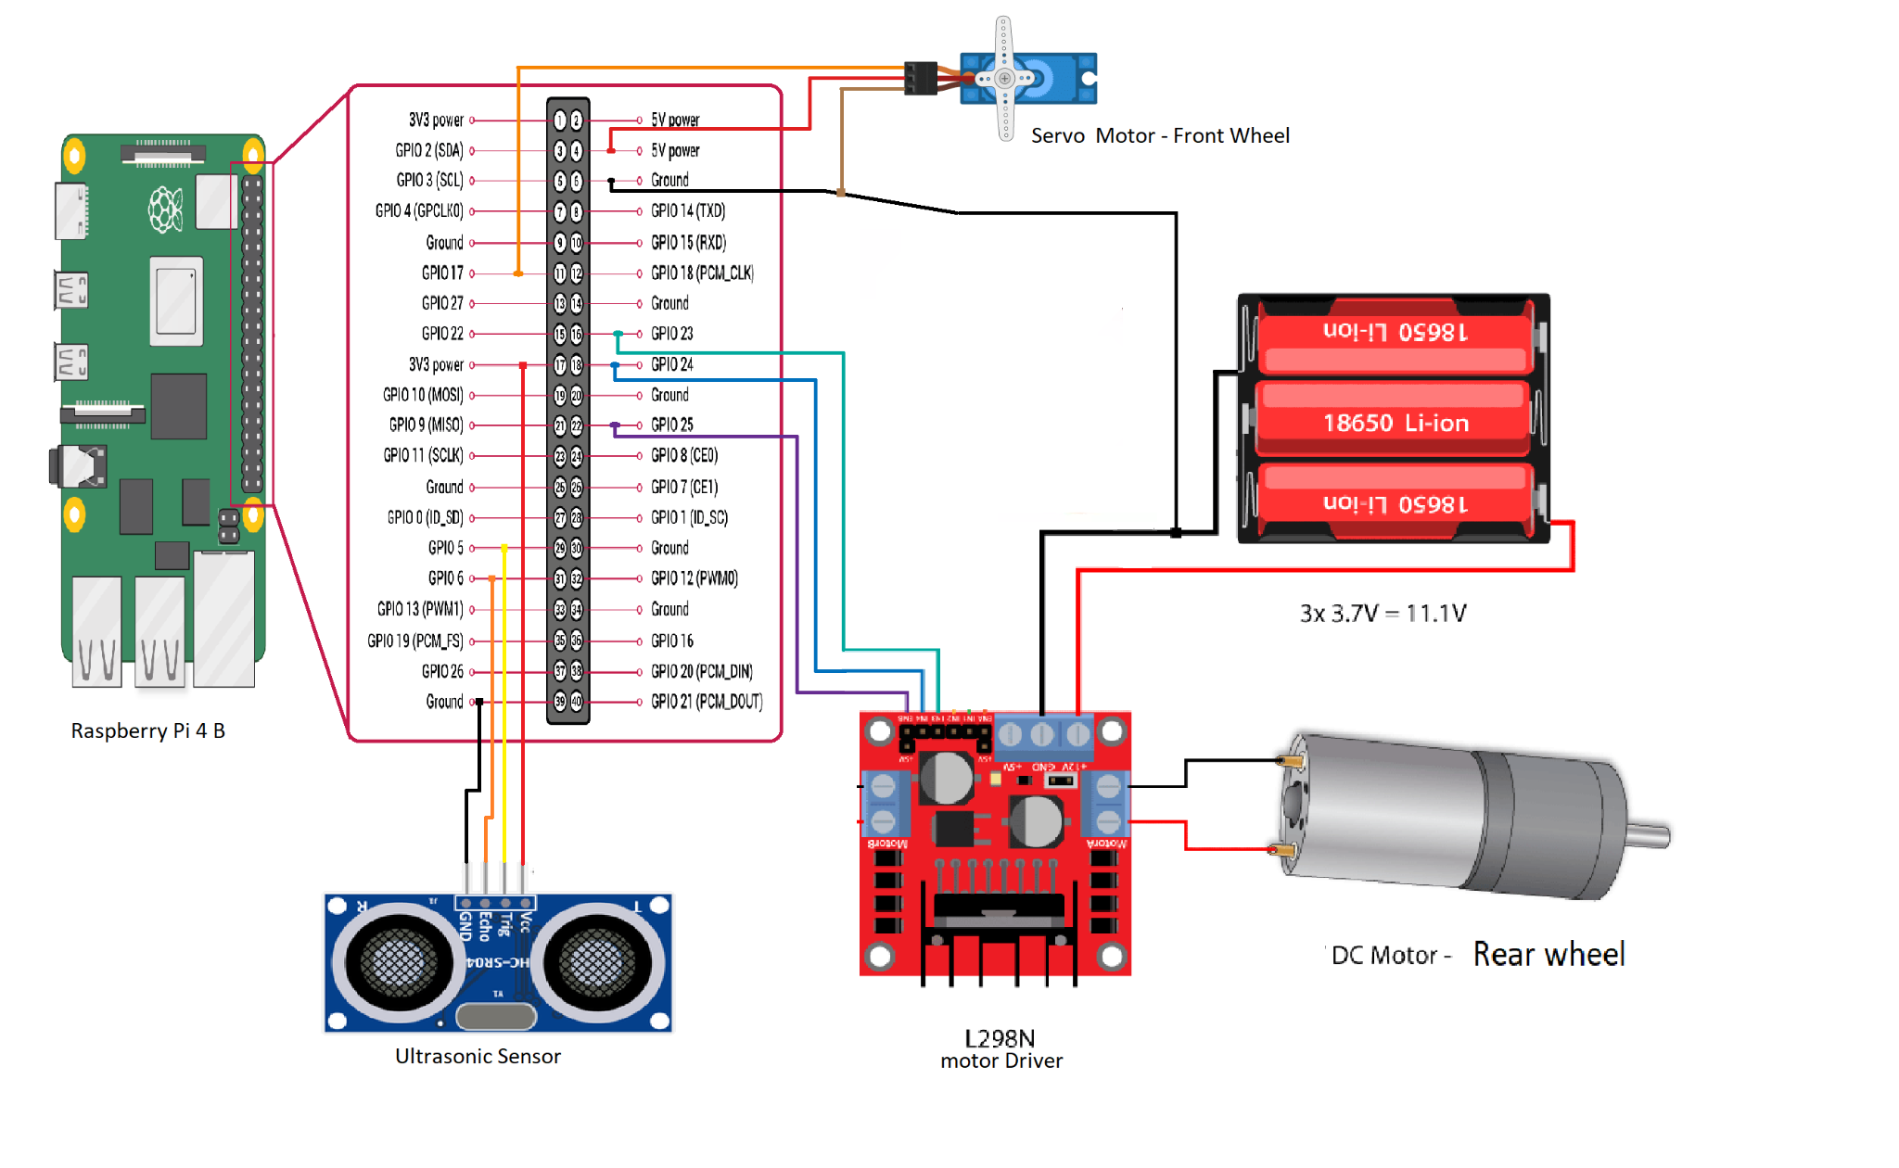

**4.3 Code Snippets**

**4.3.1 Server and client communication for data collection**

Client side:

while True:

start_t=time.time()

while len(data) < 8:

packet = client_socket.recv(1024) # 4K

if not packet: break

data+=packet

packed_msg_size = data[:payload_size]

data = data[payload_size:]

msg_size = struct.unpack("Q",packed_msg_size)[0]

while len(data) < msg_size:

data += client_socket.recv(4*1024)

end_t=time.time()

print("stream delay",end_t-start_t)

frame_data = data[:msg_size]

data = data[msg_size:]

frame = pickle.loads(frame_data)

cv2.imshow("RECEIVING VIDEO",frame)

if cv2.waitKey(1) & 0xFF == ord('q'):

break

Server side:

while True:

if not cam.isOpened():

print("camera error")

break

res,frame=cam.read()

if not res:

print("problem reading camera")

break

frame=cv2.resize(frame,(512,512),interpolation=cv2.INTER_AREA)

pframe=pickle.dumps(frame)

msg=struct.pack("Q",len(pframe))+pframe

client_socket.sendall(msg)

msg=client_socket.recv(100)

print("message recvd : ", pickle.loads(msg))

**4.3.3 Training the model**

model = Sequential()

model.add(Conv2D(filters=24, kernel_size=5,strides=2,input_shape=(320,320,3), activation='relu'))

model.add(Conv2D(filters=36, kernel_size=5,strides=2,activation='relu'))

model.add(Conv2D(filters=48, kernel_size=5,strides=2,activation='relu'))

model.add(Conv2D(filters=64, kernel_size=3,activation='relu'))#1

model.add(Conv2D(filters=64, kernel_size=3,activation='relu'))#22

model.add(Flatten())

model.add(Dense(100, activation='relu'))

model.add(Dense(50, activation='relu'))

model.add(Dense(10, activation='relu'))

model.add(Dense(1))

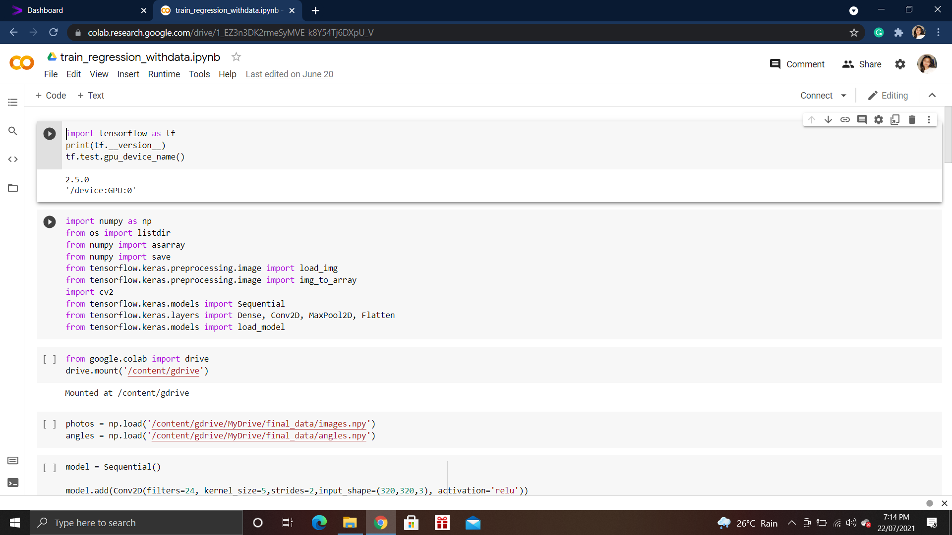

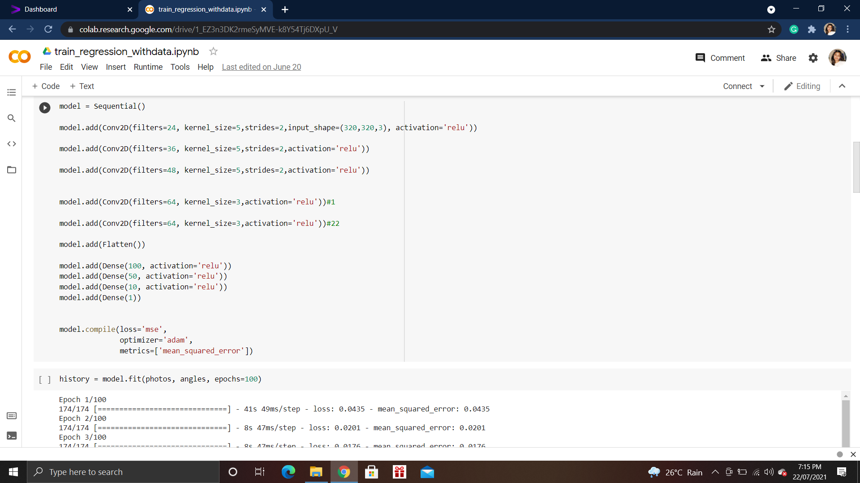

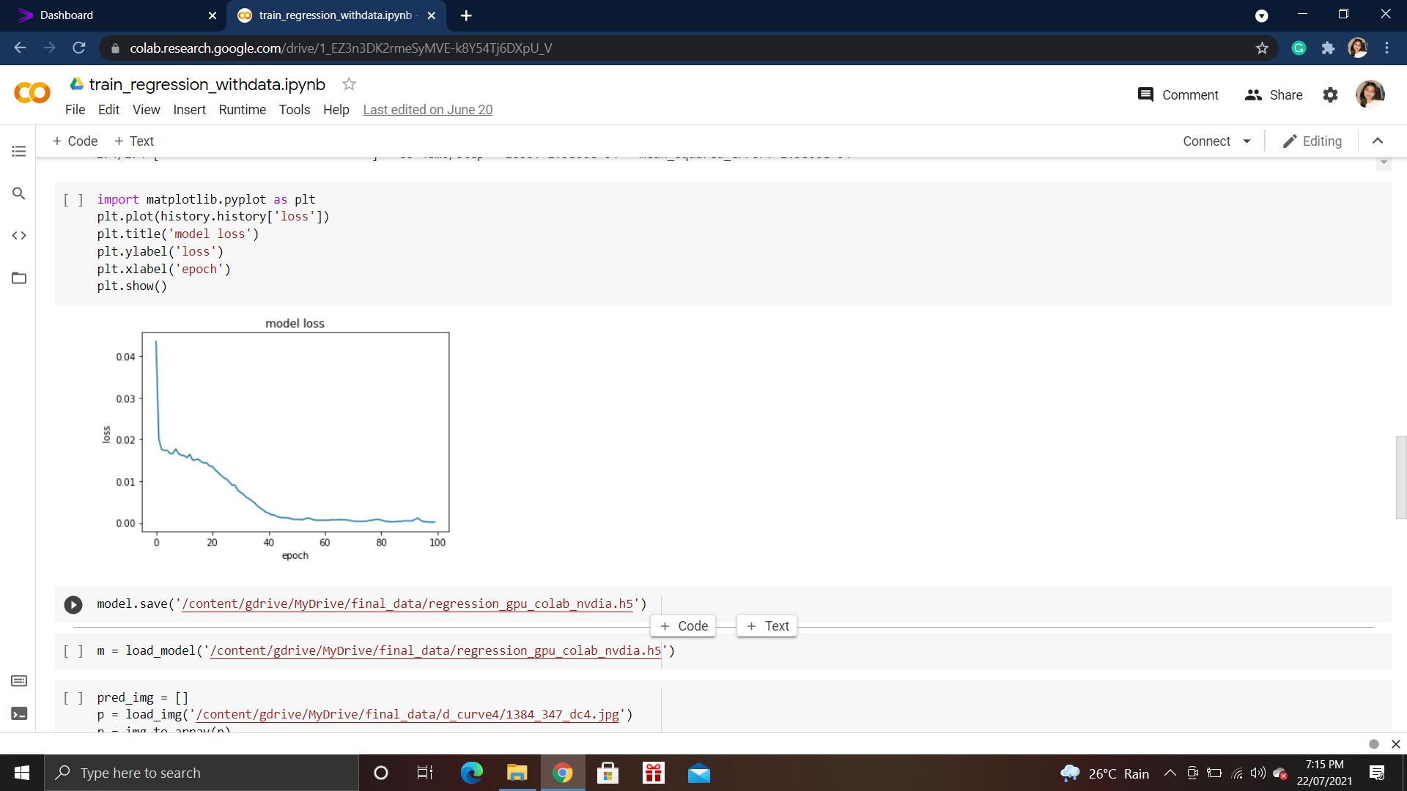

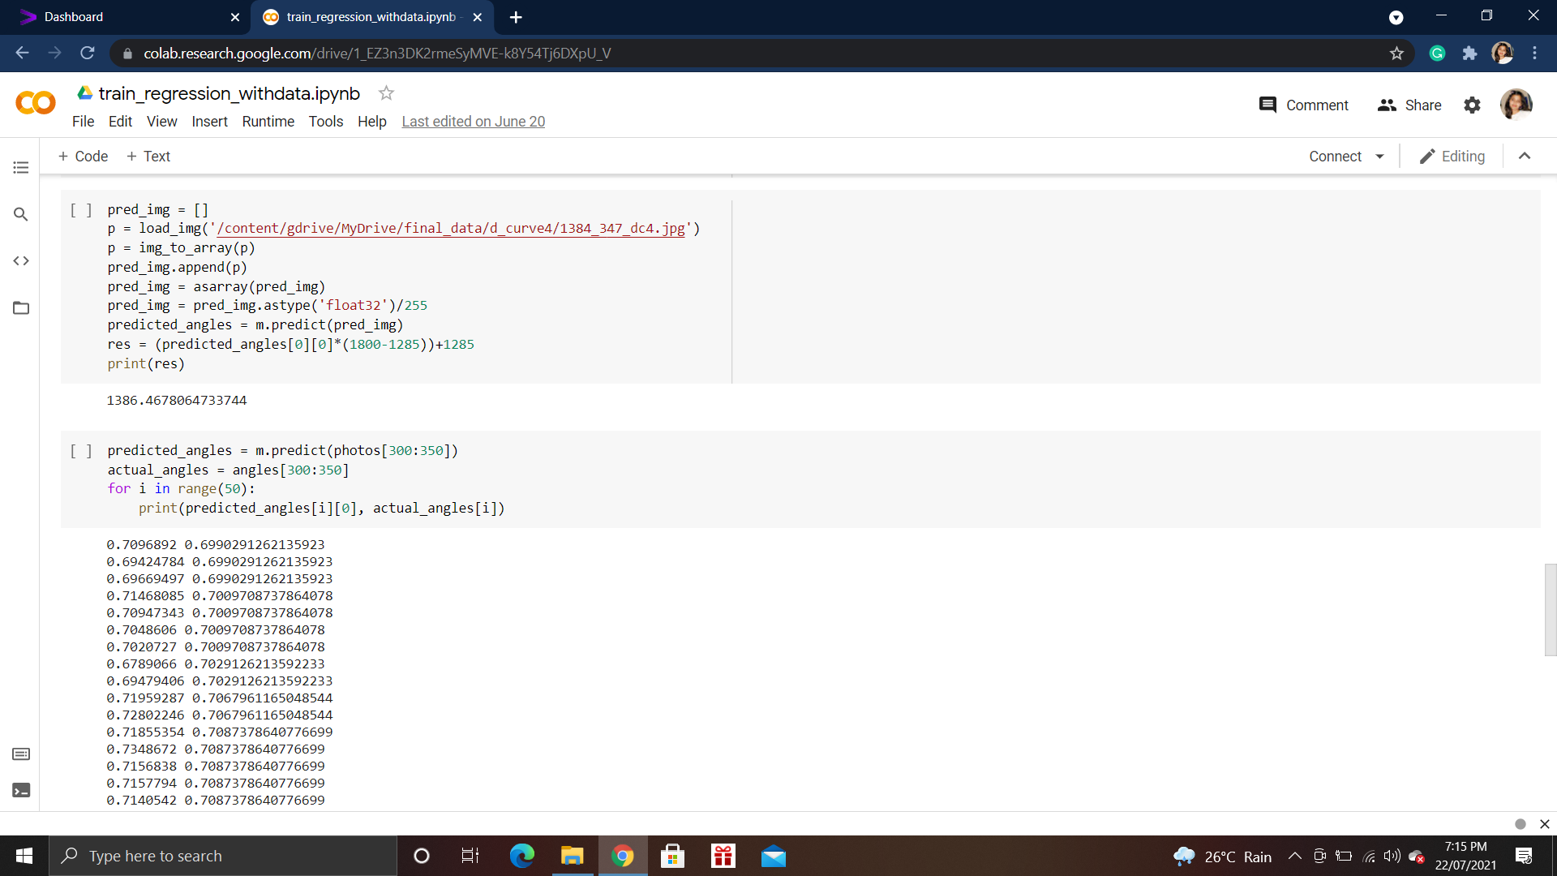

Model Architecture

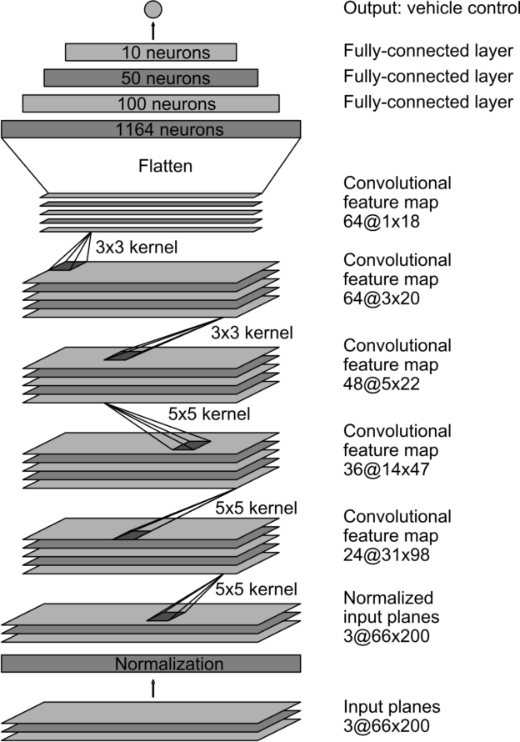



Since we need to extract the features from the image to predict the steering angle, we use convolutional neural networks for the same. The architecture of the neural network is shown in Fig:4.2

**4.3.4 Trained model Prediction**

m = load_model('regression_gpu_colab_nvdia.h5')

while True:

print('inside true')

while len(data) < 8:

packet = client_socket.recv(1024) # 4K

if not packet: break

data+=packet

packed_msg_size = data[:payload_size]

data = data[payload_size:]

msg_size = struct.unpack("Q",packed_msg_size)[0]

while len(data) < msg_size:

data += client_socket.recv(4*1024)

frame_data = data[:msg_size]

data = data[msg_size:]

frame = pickle.loads(frame_data)

frame1 = cv2.flip(frame, 0)

frame1 = cv2.flip(frame, 1)

font = cv2.FONT_HERSHEY_SIMPLEX

org = (50, 50)

fontScale = 1

color = (255, 0, 0)

thickness = 2

pred_img = []

p = img_to_array(frame)

pred_img.append(p)

pred_img = asarray(pred_img)

pred_img = pred_img.astype('float32')/255

predicted_angles = m.predict(pred_img)

angle = (predicted_angles[0][0]*(1800-1285))+1285

frame = cv2.putText(frame, 'angle pred:'+str(angle), org, font, fontScale, color, thickness, cv2.LINE_AA)

client_socket.sendall(pickle.dumps(angle))

cv2.imshow("frame",frame)

if cv2.waitKey(1) & 0xff ==27 : break

client_socket.close()

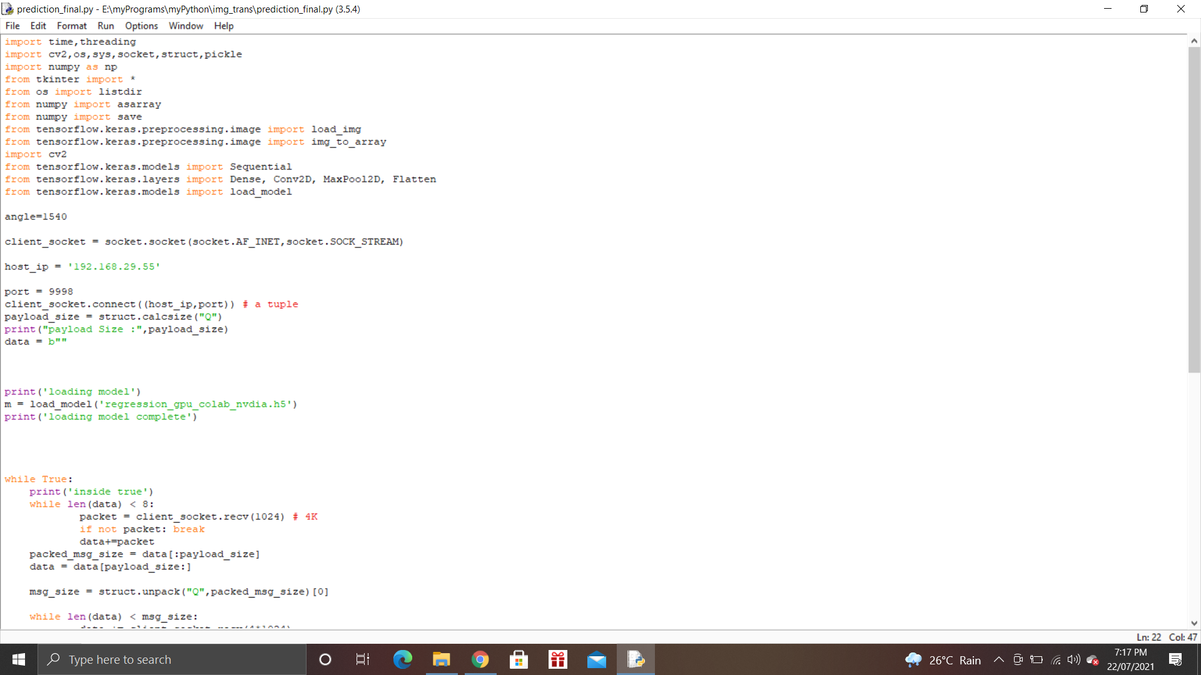

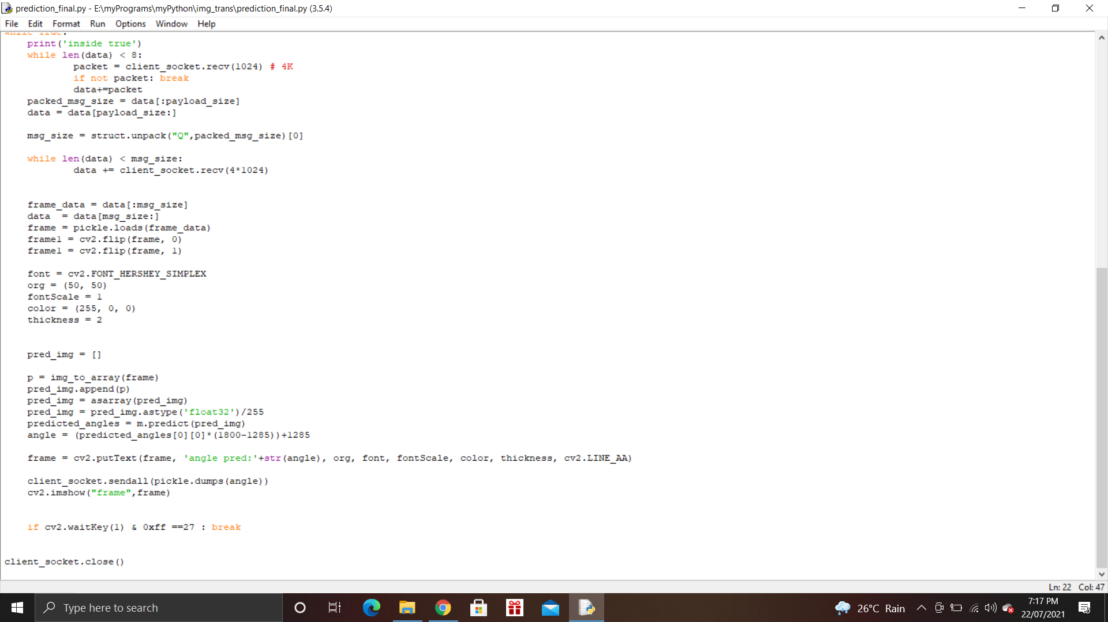

**5. EXPERIMENTATION AND RESULT ANALYSIS**

**5.1 Results**

Upon training the deep learning model with the above-mentioned architecture on the data collected by manually controlling with 100 epochs the car the following results were obtained. The data collected includes more than 5000 images along with the corresponding steering angles.

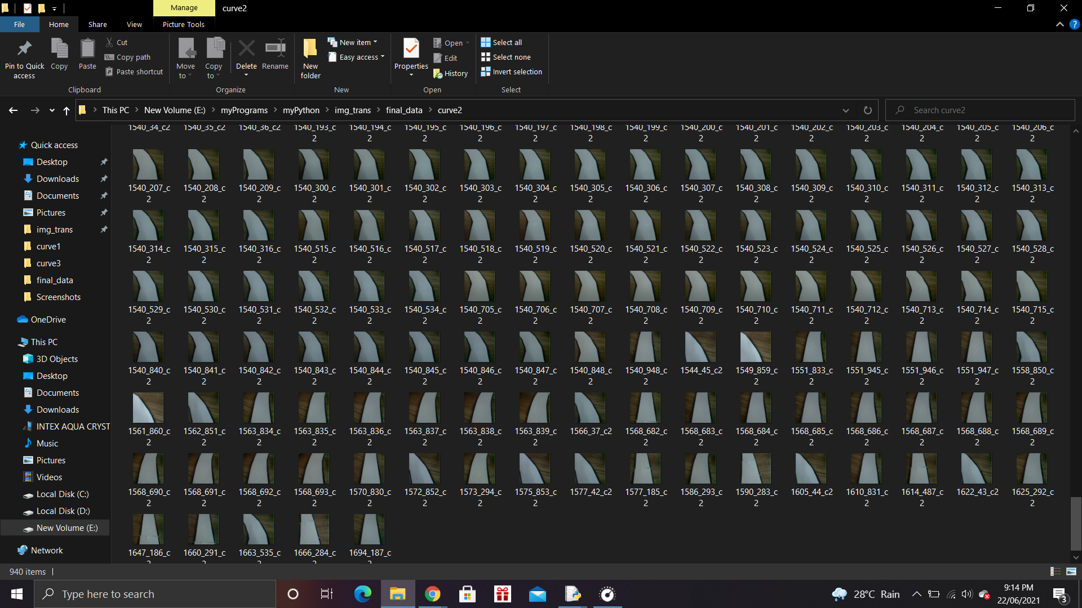

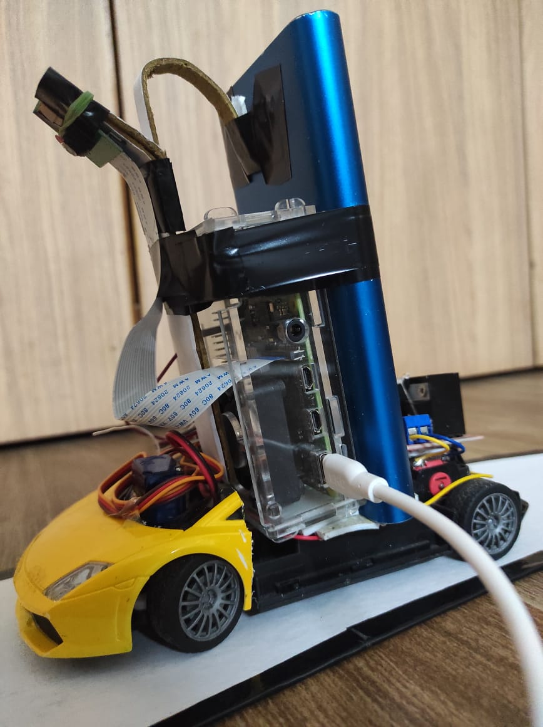



The training loss obtained was 0.000158 after 100 epochs.

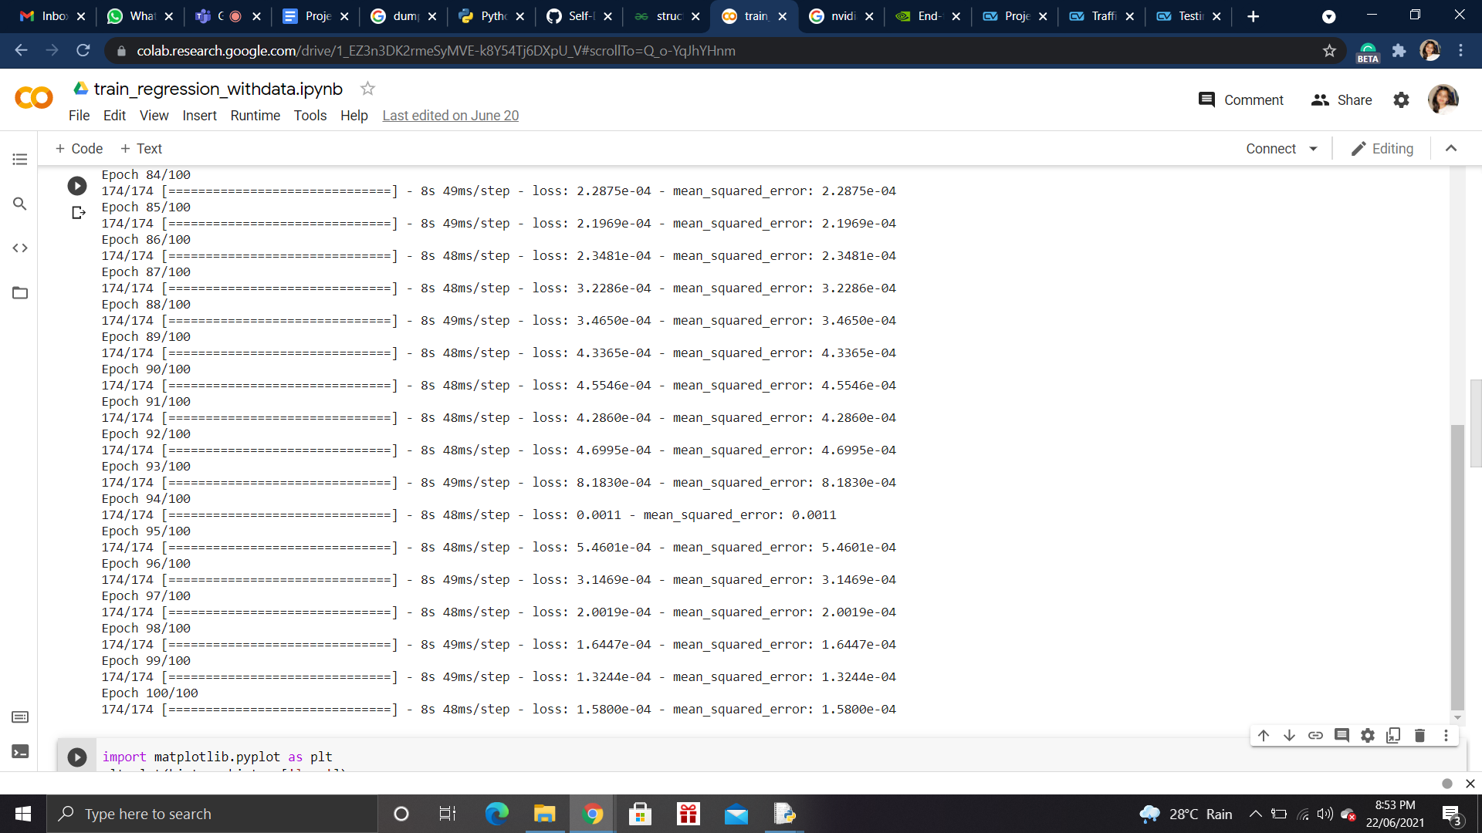

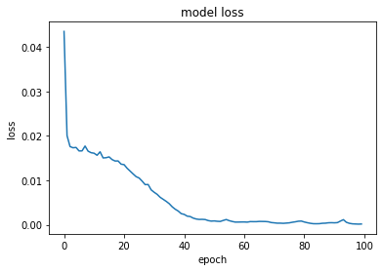





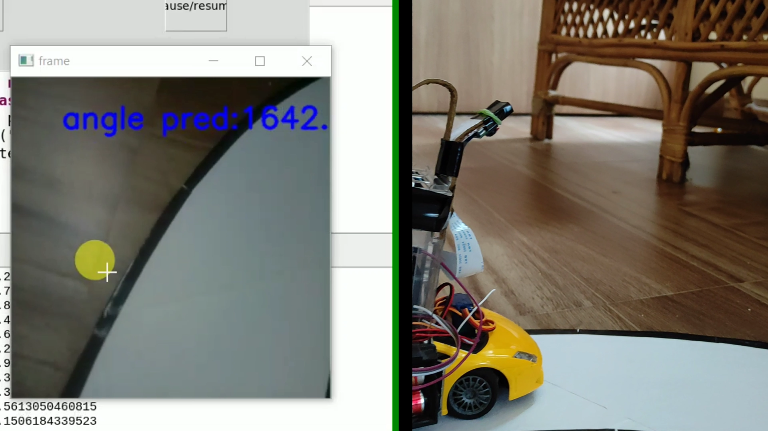



**5.2 Limitations and future works**

1. The model needs to be trained in a diverse environment along with obstacles and traffic signals which upon end to end learning would give better results in any environment.
2. More sensors and cameras with the wide-angle need to be embedded to get more detailed data to capture all the nuances while driving.

# 

# 

# 

# 

# 

# 

# **6. CONCLUSION**

The proposed self-driving car is successfully created, implemented, and tested. The vehicle is trained with more than 5,000 samples of images. In various testing done by us, it is found that despite using high-resolution V2 version of Raspbian camera lighting and different environmental conditions may affect the decision taken by the vehicle to overcome this minor issue the training should be done precisely with perfect frame rates. This report clearly describes the working methodology of our autonomous car.

Future Scope

There is a huge scope of self-driving cars in the future, the various automobile companies are improving their autonomous cars rapidly making them more accurate and secure. By using multiple cameras and sensors, the accuracy can be improved. Designing a system where every car is interconnected to nearby cars will avoid traffic congestion in future.

# 

# 

# 

# 

# 

# 

# 

# 

# 

# 

# 

# 

# 

# 

# **7. REFERENCES**

[1] Raj Shirolkar, Rohan Datar, Anushka Dhongade, Gayatri Behere “Self-Driving Autonomous Car using Raspberry Pi”, International Journal of Engineering Research & Technology (IJERT) ISSN: 2278-0181

[2] “Street Mark Detection Using Raspberry PI for Self Driving Car” by Sumardi,Muhammad Taufiqurrahman, Munawar A Riyadi published in Department of Electrical Engineering Diponegoro University, Indonesia ISSN:1693-6930

[3] Z. Chen and X. Huang, "End-to-end learning for lane-keeping of self-driving cars," 2017 IEEE Intelligent Vehicles Symposium (IV), Los Angeles, CA, 2017, pp. 1856-1860, DOI: 10.1109/IVS.2017.7995975

[4] “Design and Implementation of Autonomous Car using Raspberry Pi “ by Gurjashan Singh Pannu , Mohammad Dawud Ansari , Pritha Gupta published in **I**nternational Journal ofComputer Applications (0975 – 8887)

[5] Wang Zheng “Working model of Self-driving car using Convolutional Neural Network and Raspberry Pi”

[6] “Internet of Things: Vehicle Collision Detection and Avoidance in a VANET Environment”. Daniel Anandu Dept of Engineering and Physics University Of Central Oklahoma Edmond Ok, USA [oanadu@uco.edu](mailto:oanadu@uco.edu)

[7] “Object Detection using IoT and ML for Autonomous Car “to avoid accidents and improve road safety by Shrinath Oza and Dr.Sunil Rathod, Dr.D.Y Patil School of Engineering Lohegaon,Pune. ISSN:2278-0181

[8] Subhasis Das Mobile Traffic Sign Recognition Subhasis Das, Milad Mohammadi {subhasis, milad}@stanford.edu Stanford University

[9] Zhi Zhang, Zhihai He, Guitao Cao, and Wenming Cao, “AnimalDetection From Highly Cluttered Natural Scenes UsingSpatiotemporal Object Region Proposal sand Patch Verification”, IEEE 2016

[10] Sunitha Traffic Sign Classification and Detection Using Deep Learning Sunitha. A1 , Shanthi.S2 1,2 Department of CSE, Sri Eshwar College of Engineering, Coimbatore.

[11] A. K. Jain, "Working model of Self-driving car using Convolutional Neural Network, Raspberry Pi and Arduino," 2018 Second International Conference on Electronics, Communication, and Aerospace Technology (ICECA), 2018, pp. 1630-1635, DOI: 10.1109/ICECA.2018.8474620